**MicroSS**

**Business flow chart**

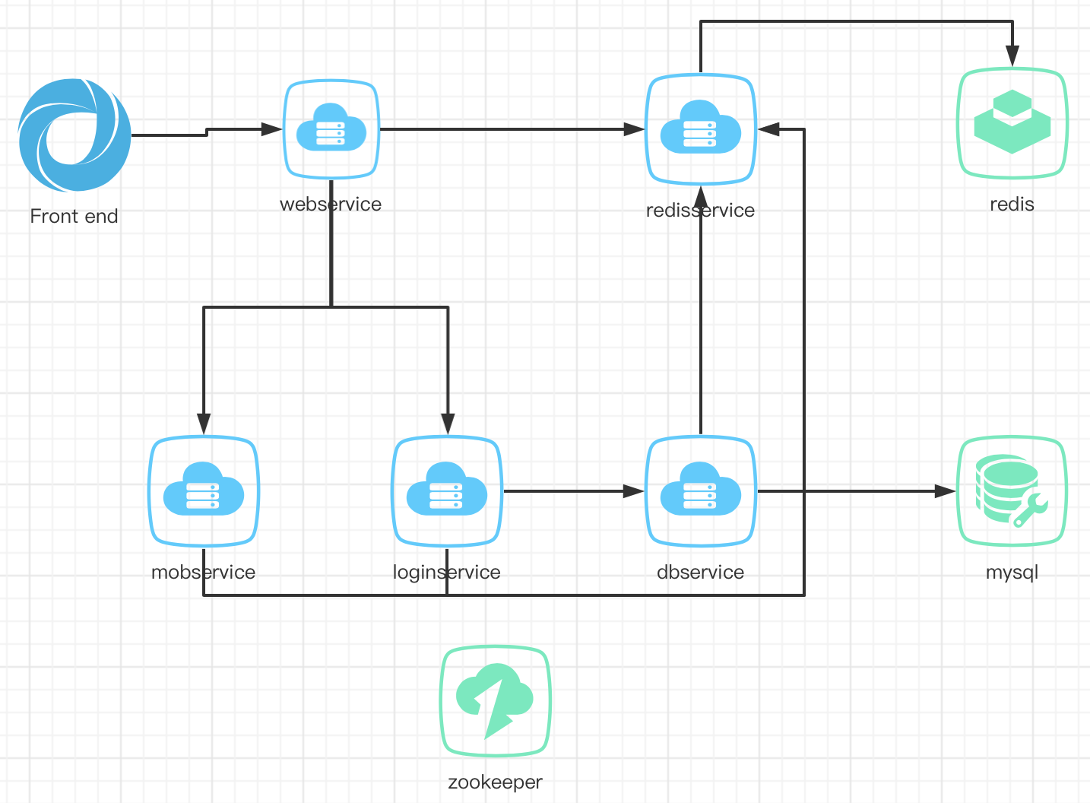

Simulation process: the front end opens the webpage, the webpage calls webservice, the webservice generates uuid, and calls redisservice to store the uuid in the redis cache, and set the time limit. Then, the webservice calls mobservice and loginservice at the same time, where mobservice simulates the mobile phone user scanning the QR code login action, and calls the redisservice service to store the user id information in the value in the corresponding uuid; during this period, the loginservice will be called every second Redisservice reads the complete information of the corresponding uuid until the uuid becomes invalid or the information is complete. If the information is complete, loginservice will call the login service dbservice, and dbservice will connect to mysql to obtain information such as the account corresponding to the user id, and generate a token to return. Of course, all services in the entire process are uniformly registered and discovered by zookeeper

**Configuration diagram**

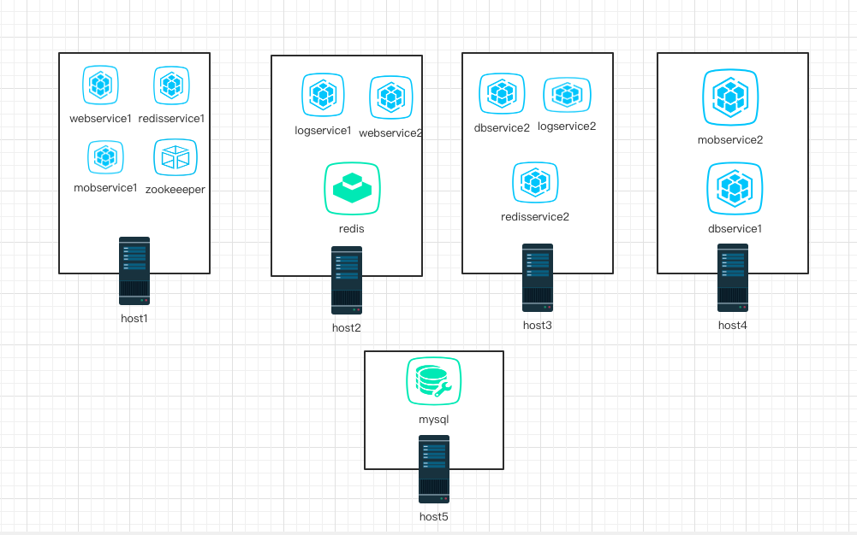

The figure above is the entire system configuration diagram. One host is isolated by a docker container and multiple services are deployed. Two container instances are deployed for each type of service, and they are all located on different hosts. Each service is registered on zookeeper. Address, and also get the address of other services through zookeeper.